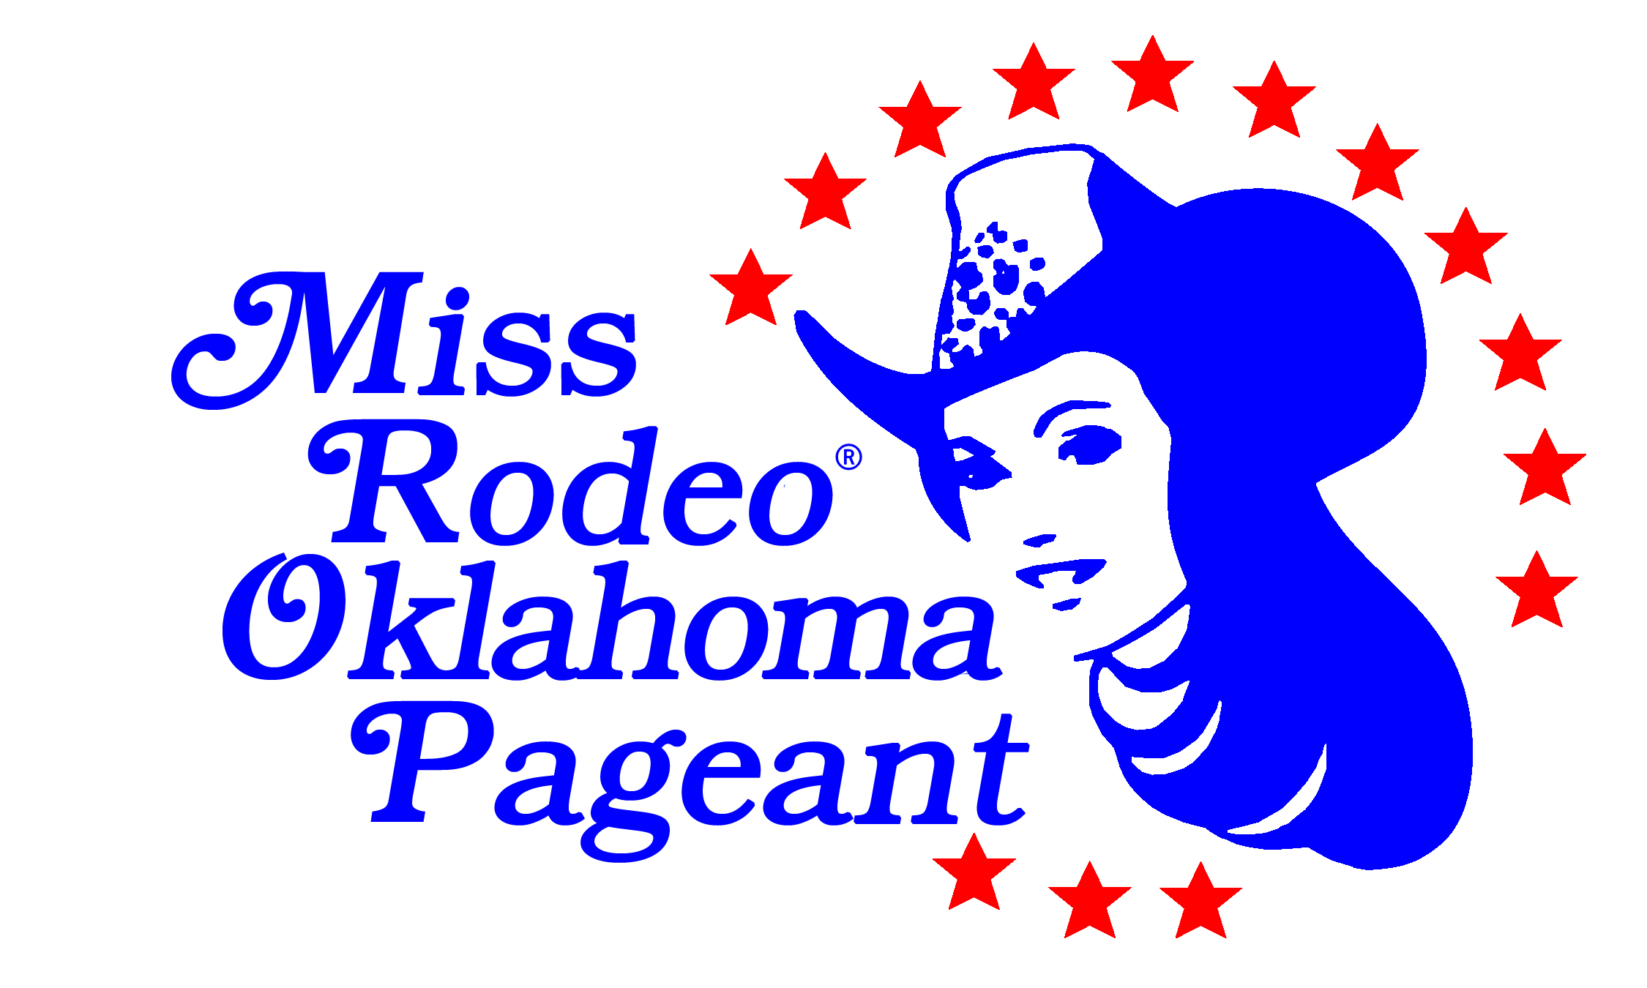

Welcome to the Miss Rodeo Oklahoma Pageant! We’re excited to have you! On the following pages, you will find:
- TEEN APPLICATION
- Liability Waivers – both are to be signed and notarized
- Sponsorship Page information for the pageant program
- Checklist for completed application
- Lodging Information
- Ticket Information
- Frequently Asked Questions

After we receive your completed entry form, we will mail to you:
- Donation tickets – a prize will be awarded to the contestant who sells the most donation tickets. Each contestant is required to sell $100 worth of tickets. (No points are given for sales.)

If you have any questions, please feel free to call the office at 405-520-7145.

Miss Rodeo Oklahoma Teen 2020
Application Form
June 5-8, 2019
Ages 13-17 years
Must have obtained the age of 13 and not yet obtained
the age of 18 as of January 1 of the competition year.

Please submit the following with completed application form:
- Copy of your birth certificate
- A photocopy of your valid Oklahoma driver’s license, if applicable.
- One vertical 8x10 head and shoulder color photograph in western attire (including a cowboy hat, no crown) that will be used for judging of the photogenic award at the pageant. No points will be awarded.
- $250 entry fee payable to the ORPC
- At least one sponsorship page and the $100 sponsorship fee

Please mail all of these document together, unless prior arrangements have been made.

Entries Must be postmarked by May 1, 2019.

The enclosed liability waiver document must be completed and returned with this application in order to compete. Please be familiar with the ORPC rulebook and please make sure you meet all of the eligibility requirements. If you have any questions, contact the ORPC office at 580-542-9233.

Send ALL completed documents and refer any questions to:

Oklahoma Rodeo Pageant Council
P.O. Box 6113
Enid, OK 73702
580-542-9233
missrodeooklahomapageant@yahoo.com

Print with blue or black ink or type. Use only the space provided. Please do not attach additional pages to this application.

Name______________________________________________ Date of Birth________________

Address____________________________________________ Phone ( ) _________________

City __________ ____Zip:_______________________________

Contestant E-mail__________________________________________________________________

Only for the purpose of providing sponsored clothing

Dress Shirt Size____________Wrangler Jean size ____________ T-Shirt Size _________________

Hat size ________________ Dress Size: __________________ Boot Size: __________________

Newspaper Name and Address:

Hometown ____________________________________________________________________

Regional ______________________________________________________________________

Email address & contact name:___________________________________________________

Pageant or Group you are representing________________________________________________
Name__________________________________________
List or describe your activities and honors:

Describe why you want to be Miss Rodeo Oklahoma Teen and what you can offer this title.

Describe your future goals:

What public service projects are important to you?

Name__________________________________________
Program Biography – in 150 words or less please provide a short biography for the pageant program.

If you are chosen as Miss Rodeo Oklahoma Teen, what do you think will be the most important aspect of the job?

RELEASE OF LIABILITY

I, the undersigned, being a non-paid contestant, applicant and participating in the Miss Rodeo Oklahoma, Miss Rodeo Oklahoma Teen, Miss Rodeo Oklahoma Princess, or Miss Rodeo Oklahoma Sweetheart Scholarship Pageant, which is sponsored by the Oklahoma Rodeo Pageants Council, Inc. and recognizing that said sponsor is a non-profit organization; and recognizing the non-profit nature of the pageant, and as an express consideration for being allowed to enter the contest, hereby release said Oklahoma Rodeo Pageants Council, Inc. from any and all claims or demands for liability for accidents or any other liabilities and makes said agreement for herself, her heirs and executors and states that she is of lawful age and legally entitled to make this complete release or if she is a Teen, Princess or Sweetheart contestant, one parent is to sign this release. All activities associated with the Miss Rodeo Oklahoma, Miss Rodeo Oklahoma Teen, Miss Rodeo Oklahoma Princess and Miss Rodeo Oklahoma Sweetheart Scholarship Pageant officially ends at 3:00 p.m. on June 9, 2018. After that time, Oklahoma Rodeo Pageants Council, Inc. or any of their representatives shall have no responsibility whatsoever in directing or overseeing any of the activities or affairs of any of the Contestants.

Following the completion of the Miss Rodeo Oklahoma Pageant competition, each Miss Rodeo Oklahoma Sweetheart titleholder will assume all responsibility and liability for their person, possession and affects as they carry out their title. Any and all responsibility includes, but is not limited to, participation in all equestrian activities and further indemnifies the Oklahoma Rodeo Pageants Council, Miss Rodeo Oklahoma Sweetheart Pageant and any and all of its affiliates and associates.

Contestant: ______________________________ Date:_________________________
Parent or Guardian: ___________________________________
Subscribed and sworn to before me, a Notary Public, with and for the County of
__________________, State of Oklahoma, on this ____day of ___________ 20___.
Notary Public ___________________________________
My Commission #: ___________________
My Commission expires:_______________

RULES & REGULATIONS

I certify that I have read and understand the Miss Rodeo Oklahoma Pageant Rulebook, Titleholder Handbook, and Contract and hereby agree to all rules and stipulations set forth by the Oklahoma Rodeo Pageants Council, Inc.

IN WITNESS THEREOF, I have hereunto set my hand and seal on this ____ day of ______________, 20___.

CONTESTANT: _________________________________________

WITNESS: ______________________________________________

The undersigned, being first duly sworn on oath, deposes and says that the statements and representations contained in this Contract are true and correct to the best of her knowledge, information and belief on this ____ day of ______________, 20___.

________________________________
Notary Public for the State of Oklahoma
________________________________
Printed Name
My Commission #: ________________
My Commission Expires: ___________

PROGRAM INFORMATION

A program featuring contestants’ pictures and bios as well as pageant information will be available at the pageant. Contestants are required to purchase one full page in the program for $100. This page may feature the contestant or thank sponsors, family, and friends.

Contestants are encouraged to use the sale of sponsorship advertising to assist them with pageant expenses. While each page costs the contestant $100, the advertising on the page can be sold at any price the contestant chooses. For example, 10 business card size advertisements will fit on one page. If a contestant chooses to sell business card size ads for $25 each, the contestant would have total sales of $250. After paying for the page, this would leave the contestant $150 to use toward pageant expenses.

Contestants may sell as many advertising pages as they wish, but must sell as least one page. Additional pages will be $100 for a full page and $50 for a half page.

Send a final layout of your page exactly as you would want it to appear in the program. You may include pictures (which can be taped in place on the paper), complete the page on the computer or cut and paste business cards and type. It is recommended to send your sponsorship page in .jpg or PDF file on a CD or you may email to: thousevid@sbcglobal.net. If you email, send a hard copy with your application. All pages will be printed in black and white. Contestants may let their creativity run wild – as long as the page is professional and appropriate. If you have questions about the page, please call Tom House at 405-650-2544.

COMPLETED TEEN APPLICATION CHECKLIST
Please make sure the following are included with your application.
_____ Copy of birth certificate
_____ Copy of your valid Oklahoma Driver’s License, if applicable
_____ One vertical 8x10 head and shoulder color photograph in western attire (including a cowboy hat, no crown). Include a picture release if applicable, for judging purposes.
_____ Entry fee payable to the ORPC ($250 for Teen)
_____ Sponsorship page layout
_____ Sponsorship page fee payable to the ORPC ($100 per page)
_____ Signed and notarized Release of Liability
_____ Signed and notarized Statement that Rulebook, Handbook and Contract have been read and understood
_____ Ticket Reservations and Payment
_____ $25 Stall Reservation and Payment for each stall used. Shavings not included
_____ Coggins Certificate for each horse

THE FOLLOWING ITEMS ARE TO BE BROUGHT TO THE PAGEANT:
______You will be provided a sponsored outfit and you will need to bring some tank tops, leggings and
accessories (jewelry, hats, headbands, belts, shoes, etc.)
______ Donation ticket money

Oklahoma Rodeo Pageants Council
P.O. Box 6113
Enid, OK 73702
missrodeooklahomapageant@yahoo.com

Lodging Information

Hampton Inn & Suites
2814 Williams Ave.
Woodward, OK 73801
580-254-5050

- Rooms will be $89.00 per night, plus tax.
- Room rate includes free breakfast.
- Reservations need to be made by calling before May 20, 2019. We recommend making reservations as early as possible to ensure the discounted rate.
- You must state that you are with the Miss Rodeo Oklahoma Pageant to receive the discounted rate. All family and friends are welcome to stay at the host hotel as well at this rate.

There are RV hook ups at the arena with electricity and water that are available for $100 for the week, paid to the ORPC.

You are encouraged to represent your title Saturday night at the rodeo, during the grand entry.

Stall and Arena Information

Woodward Elks Rodeo Arena
105 Temple Houston Dr.
Woodward, OK 73801

- You will need a negative coggins certificate for each horse.
Contestants will pay ORPC $25 for the week, for each horse stall used at the arena. Shavings are not included.

Ticket Information for Family and Friends

Ticketed events are as follows:
- Formal Fashion Show, lunch included – $30 for adults; $15 for 12 and under
- Speeches $10 for adults; $5 for children
- Coronation – $20 for adults; $10 for 12 and under
- All contestant tickets are covered in their entry fee.
- Each contestant & 1 guest will receive a pass for each rodeo performance.

Reservations are strongly encouraged. If reservations are not made, meal availability will not be
guaranteed, and the cost will be $5.00 more at the door.

2020 Miss Rodeo Oklahoma Scholarship Pageant Ticket Reservations

Name_______________________________________________________________________
Address________________________________________ Phone ( ) ________________
City & State____________________________________________________Zip____________
E-mail___________________________________

Event: $ per ticket: # of tickets: Amount Due:
Orientation* No charge __________ ____$0____
Horsemanship* No charge __________ ____$0____
Speeches $10 adults __________ __________
$5 children ** __________ __________

Fashion Show, $30 adults __________ __________
Lunch included. $15 children** __________ __________

Coronation $20 adults __________ __________
$10 children** __________ __________
Stalls $25 for each stall __________ __________

RV Hook-up $100 for week __________ __________

Total Enclosed __________
Make checks payable to ORPC.
* While there is no charge to attend these events, we need an accurate head count.
** Children are ages 12 and under.
Frequently Asked Questions

1. What are the wardrobe requirements?

See the Schedule

2.What are the pageant ticket prices?

See “Ticket Information Sheet” in this application. Tickets are $5 more when purchased
at the door.

3. Rodeo tickets may be purchased at the gate. Information for rodeo tickets can be found at www.woodwardelksrodeo.com.

4. Will we have to carry a flag in horsemanship?

The Miss, Teen and Princess contestants will be required to carry a flag as part of horsemanship.
Contestants must furnish their own flag boot. Miss & Teen Contestants may be asked to carry a flag at the
rodeo. The themes for each night are: Wednesday-Purple for Domestic Violence; Thursday-no theme; Friday-Patriotic; Saturday-Pink Night.

5. Where do I find study material for the written test and impromptu questions?

While this list is not all-inclusive, it will give you a good start:

ProRodeo Sports News (Miss and Teen Only)
Media Guide (Miss and Teen only)
RodeoRoyalty.com – this gives several sample impromptu questions
National news sources

6. Where/how do I purchase programs? Programs can be purchased during the pageant for $10 each.

7. You are encouraged to represent your title Saturday night at the rodeo, during the grand entry.

